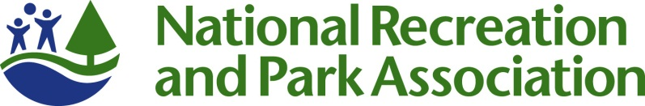
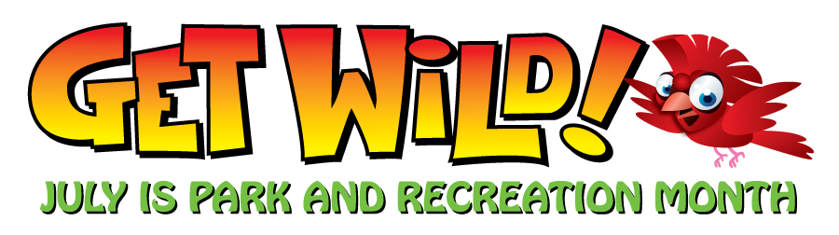
Park and Recreation Month 2012
“GET WILD!” Fact Sheet

- Since 1985, America has celebrated July as the nation’s official Park and Recreation Month. In 2009, the U.S. House of Representatives officially mandated July as “Park and Recreation Month.”

- This July we are encouraging you and your community to GET WILD about parks and recreation!

- Our nation’s parks and recreation are integral catalysts for healthy, active communities and foster social connectivity as well as physical, mental and environmental health. You can experience these benefits by visiting your local park and recreation area any time of the year, and especially during Park and Recreation Month.

- Hundreds of park and recreation agencies across the country will be showing their wild side during Park and Recreation Month with special events, programs and other activities.

- In addition to visiting a park or recreation area during July, NRPA has created several ways to celebrate Park and Recreation Month:

  - Participate in the GET WILD Geocache Contest;
  - Send in photos or videos with the official GET WILD poster showing how “wild” you are about your parks and recreation ; and
  - Sign the GET WILD pledge.

- The NRPA GET WILD Geocache Contest is an outdoor treasure hunting game, where players locate hidden containers, called geocaches using GPS-enabled devices or mobile phones and then share their experiences online. NRPA will give away 5 GPS devices to those that enter the contest through the NRPA Facebook page (more about the contest is available on Facebook).

- You can find out about all of the GET WILD initiatives, including the contest, pledge and access downloadable materials by visiting www.nrpa.org/July.

- Don’t forget to like NRPA on Facebook and follow us on Twitter, @NRPA_News (#NRPAGetWild) for the latest about Park and Recreation Month.

